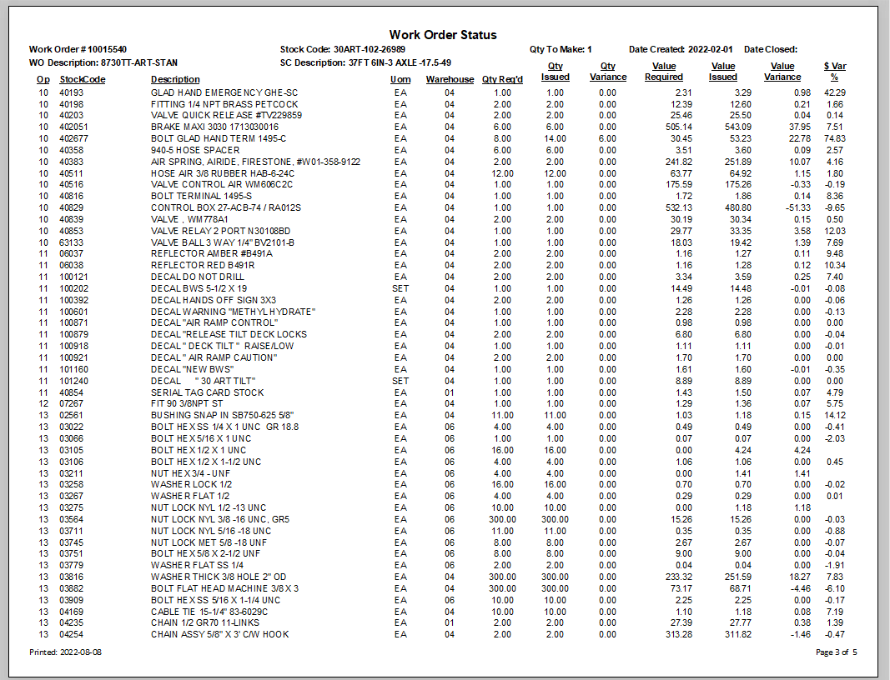
This shows the cost difference
Difference between money $$ required and issued.
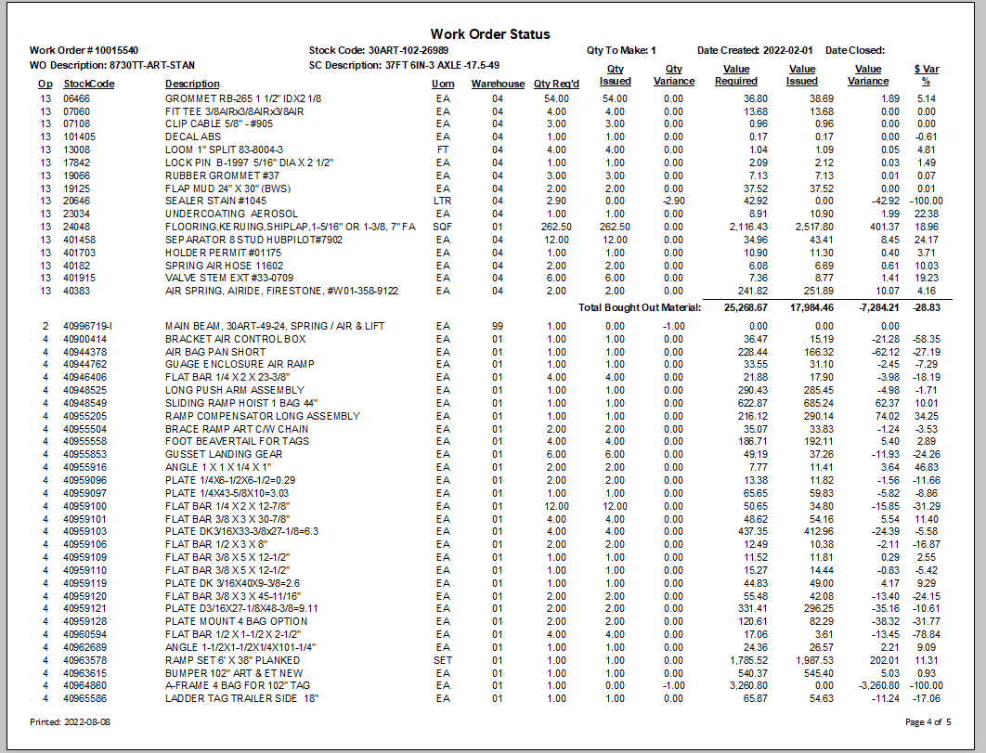
Report is divided into bought out, made in, subcontract and labor cost $$.
This is the bought-out subtotal.

